Adelaide Outriggers Inc
Sponsorship Opportunities

Outrigger Canoeing

Outrigger Canoe paddling has its origins in the development and spread of the coastal culture of the Pacific Rim region about 30,000 years ago, with canoes playing an integral role in the survival and transmigration of ancient cultures.
Outrigger Canoe racing is a relatively young sport in Australia. Seventy years after Hawaii’s first Outrigger Canoe Club was established, the first club in Australia was formed in 1978 on the Gold Coast. The first Club in Sydney was formed in 1989. The first Australian Championships were held the same year.
Outrigger canoe racing has become one of the fastest growing aquatic sports in Australia, with the development of clubs outside the sport’s power base in northern Queensland and the Whitsunday region, making it a national sport. Major races in outrigger canoes are undertaken in six-seater boats (OC6s) and single-seat OC1s, with competition at a global & elite level spanning the world.
Races range from sprints of 500 and 1000 metres to endurance events from 8km to 42km
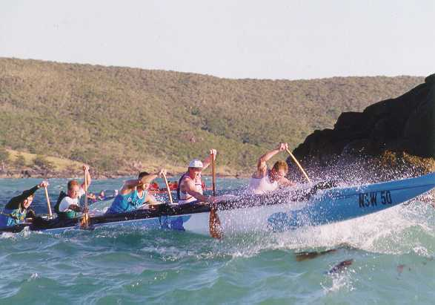

Adelaide Outriggers Inc Background

Adelaide Outriggers Inc was established in 1997. It is the first and presently only outrigger canoe club within South Australia. Its operations at the Port Adelaide Rowing Club on the Port River, with a summer season base at the Somerton Surf Life Saving Club.
The aim of the Adelaide Outriggers Inc. is to encourage as many individuals as possible to engage in the sport, and then assist in the establishment of further clubs, to foster a state regatta season. Such growth would serve to attract interstate competitors and teams, and greatly enhance South Australia’s ability to compete in interstate and overseas competitions.
Adelaide Outriggers is affiliated with the Australian Outrigger Canoe Racing Association and the Somerton Surf Life Saving Club and Port Adelaide Rowing Clubs with close links to the Dragonboat Association of South Australia, Canoe South Australia.
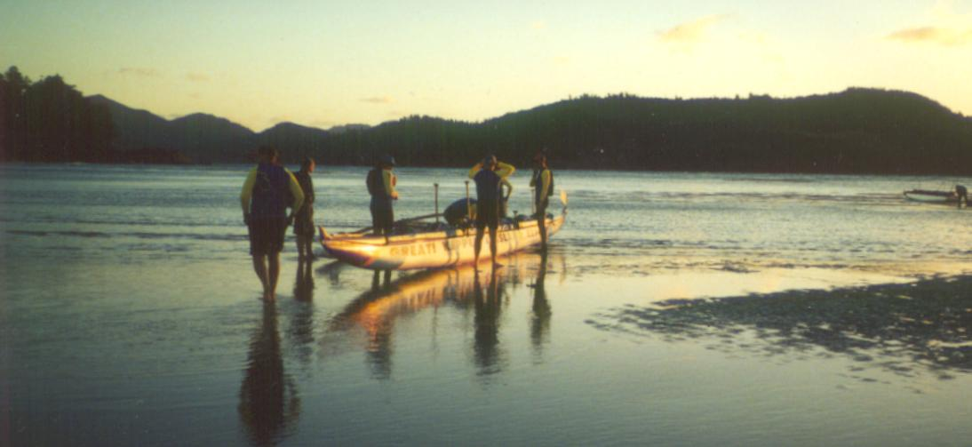

Adelaide Outriggers Activity Profile

Adelaide Outriggers Inc. held several “Open Days” inviting the public to come & try what is a relatively new exiting sport. Membership is open to anyone interested in canoeing activities. The club is committed to promoting this new sport and its health & fitness benefits to participants; and made a commitment to SmartPlay, SunSmart, and non-smoking policies to enhance the safe and healthy environment promoted by the sport.
Adelaide Outriggers is an open and progressive club with a growing membership of thirty ranging from juniors (aged from 10 to 18) to senior masters (aged over 45).
Adelaide Outriggers competes in various major events: Murray 100 km Marathons and regattas at Hamilton Island, Victoria and NSW.
The crews are regularly seen between Port Stanvac, Glenelg and Port Adelaide as well around the Torrens and Garden Islands environs. Training sessions and demonstrations are often held on suburban and south coast beaches.

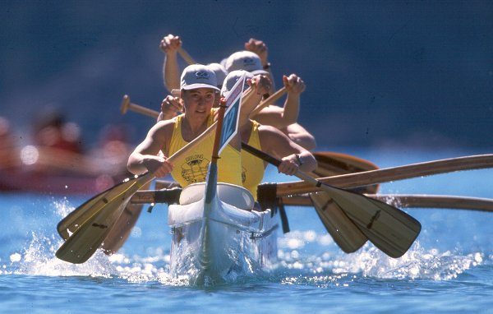

Sponsorship Options

Sponsors may assist Adelaide Outriggers Inc by selecting from the following sponsor options
- Gold Sponsor – One @ $2000.00
- Silver Sponsor – Two @ $1000.00
- Bronze Sponsor – Five @ 500.00
- Equipment Sponsor – Negotiable
- Event Sponsor – Negotiable
Sponsors will be regularly informed of the activities of the club in promoting your message by quarterly reports by the Club President.
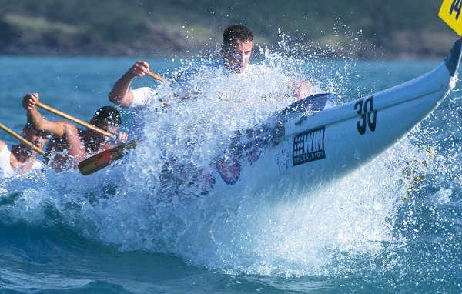

Gold Sponsorship - $2000.00.

The Gold Sponsor will receive the prime opportunity to obtain maximum exposure for their contribution.
Gold Sponsor Advertising will be displayed at all participating venues and the Sponsor will be acknowledged at every possible occasion ie. Trophy Presentations, Media Interviews.
Details can be negotiated with the Field Officer. Benefits can include the following:
- Signage on one of the Club’s OC6 Canoes
- Signage on vehicles towing boats and trailers.
- Signage on or alongside tentage at all local, interstate and national events and functions.
- Signage on race apparel worn by team competitors during local and national competitions.
- Product stalls during Club events and sales of sponsor’s products.
- Signage on Club Official Web Page.
- Inclusion in Annual Report and all Club Newsletters as a major sponsor.
- Exclusive use of product by Club (where suitable and applicable).
- Promotion of Company/Business to Club members and general community.
- Inclusion on all advertising materials produced by Club
- Advertising of Company logo on Sponsors supplied Flags.

Silver Sponsorship - $1000.

This entitles the sponsor to a 12 month sponsorship agreement with Adelaide Outriggers Inc. Your Company/Business name is displayed in the annual general report and the Club newsletters.
Silver Sponsor Advertising will be displayed at all participating venues and the Sponsor will be acknowledged at every possible occasion ie. Trophy Presentations, Media Interviews.
- Signage on one of the Club’s OC6 Canoes
- Advertising of Company logo on Racing Uniforms.
- Advertising of Company logo in Club Newsletters.
- Advertising of Company logo on Club Letterhead.
- Advertising of Company logo on Marquee Banner.
- Advertising of Company logo on Sponsors supplied Flags.
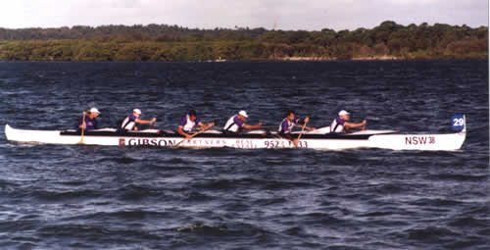

Bronze Sponsorship - $500.

This entitles the sponsor to a 12 month term sponsorship agreement with Adelaide Outriggers Inc. Your Company/Business name and logo is promoted on particular club equipment nominated by the Club. Your Company/Business name is also displayed in the annual general report and the Club newsletters.
Bronze Sponsor Advertising will be displayed at all participating venues and the Sponsor will be acknowledged at every possible occasion i.e. Trophy Presentations, Media Interviews.
- Advertising of Company logo on Marquee Bunting.
- Advertising of Company logo in Club Newsletters.
- Advertising of Company logo on Sponsors supplied Flags.
- Small sign on the tail of on of the Club OC6 canoes.
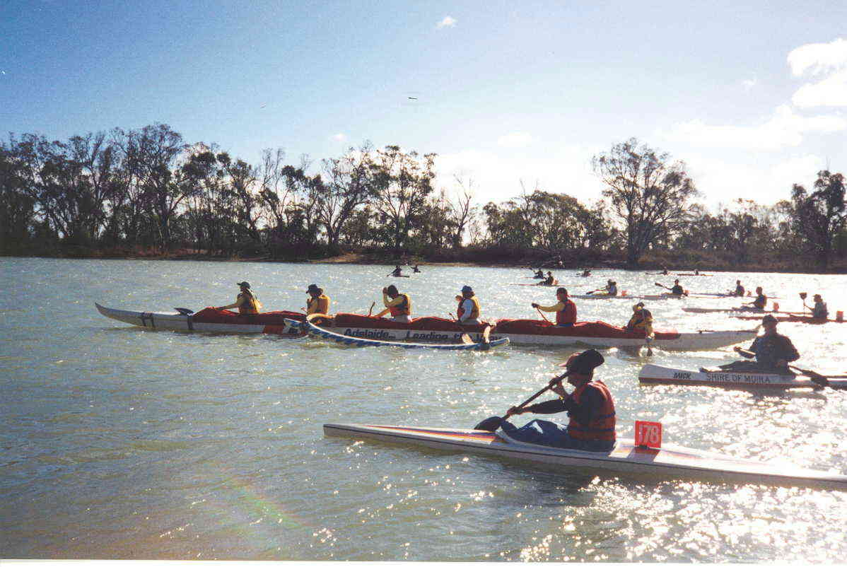

Equipment Sponsorship: Contribution of $2,000 per annum over a 2 year minimum period.

Sponsors who contribute $2,000 per annum(Agreement for a 2 year minimum period) include benefits of displaying your message on one of our six seater outrigger canoes or on particular Club/beach equipment nominated by the Club. Your Company/Business name is also displayed in the annual general report and the Club newsletters and on the Adelaide Outriggers Inc Internet Web site.
Your Company/Business name and logo is applied exclusively by Club Management at all local, interstate and national carnivals and major events.
Six seater outrigger canoes are fourteen metres long and display a panel half a metre high above the water line. The canoes travel routinely travel 100 metres offshore between Port Stanvac and Largs.

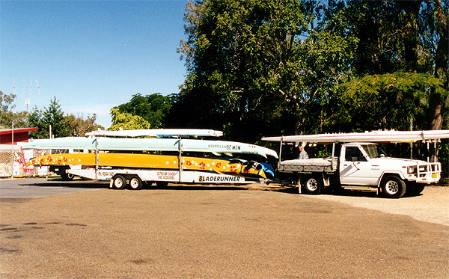

Event Sponsorship:

Adelaide Outriggers is intending to host a regatta in the 2003 – 2004 season and is seeking sponsors for the naming rights to this event.
Organisations may be interested in sponsoring our “come and try” sessions held on metropolitan and south coast beaches.
Adelaide Outriggers is also able to supply equipment and trained paddlers and coaching staff for that special corporate event or fundraiser

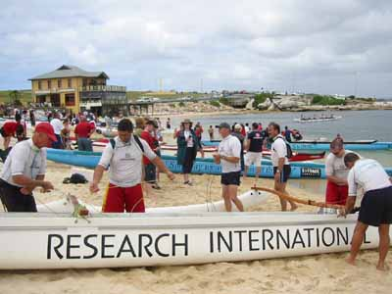

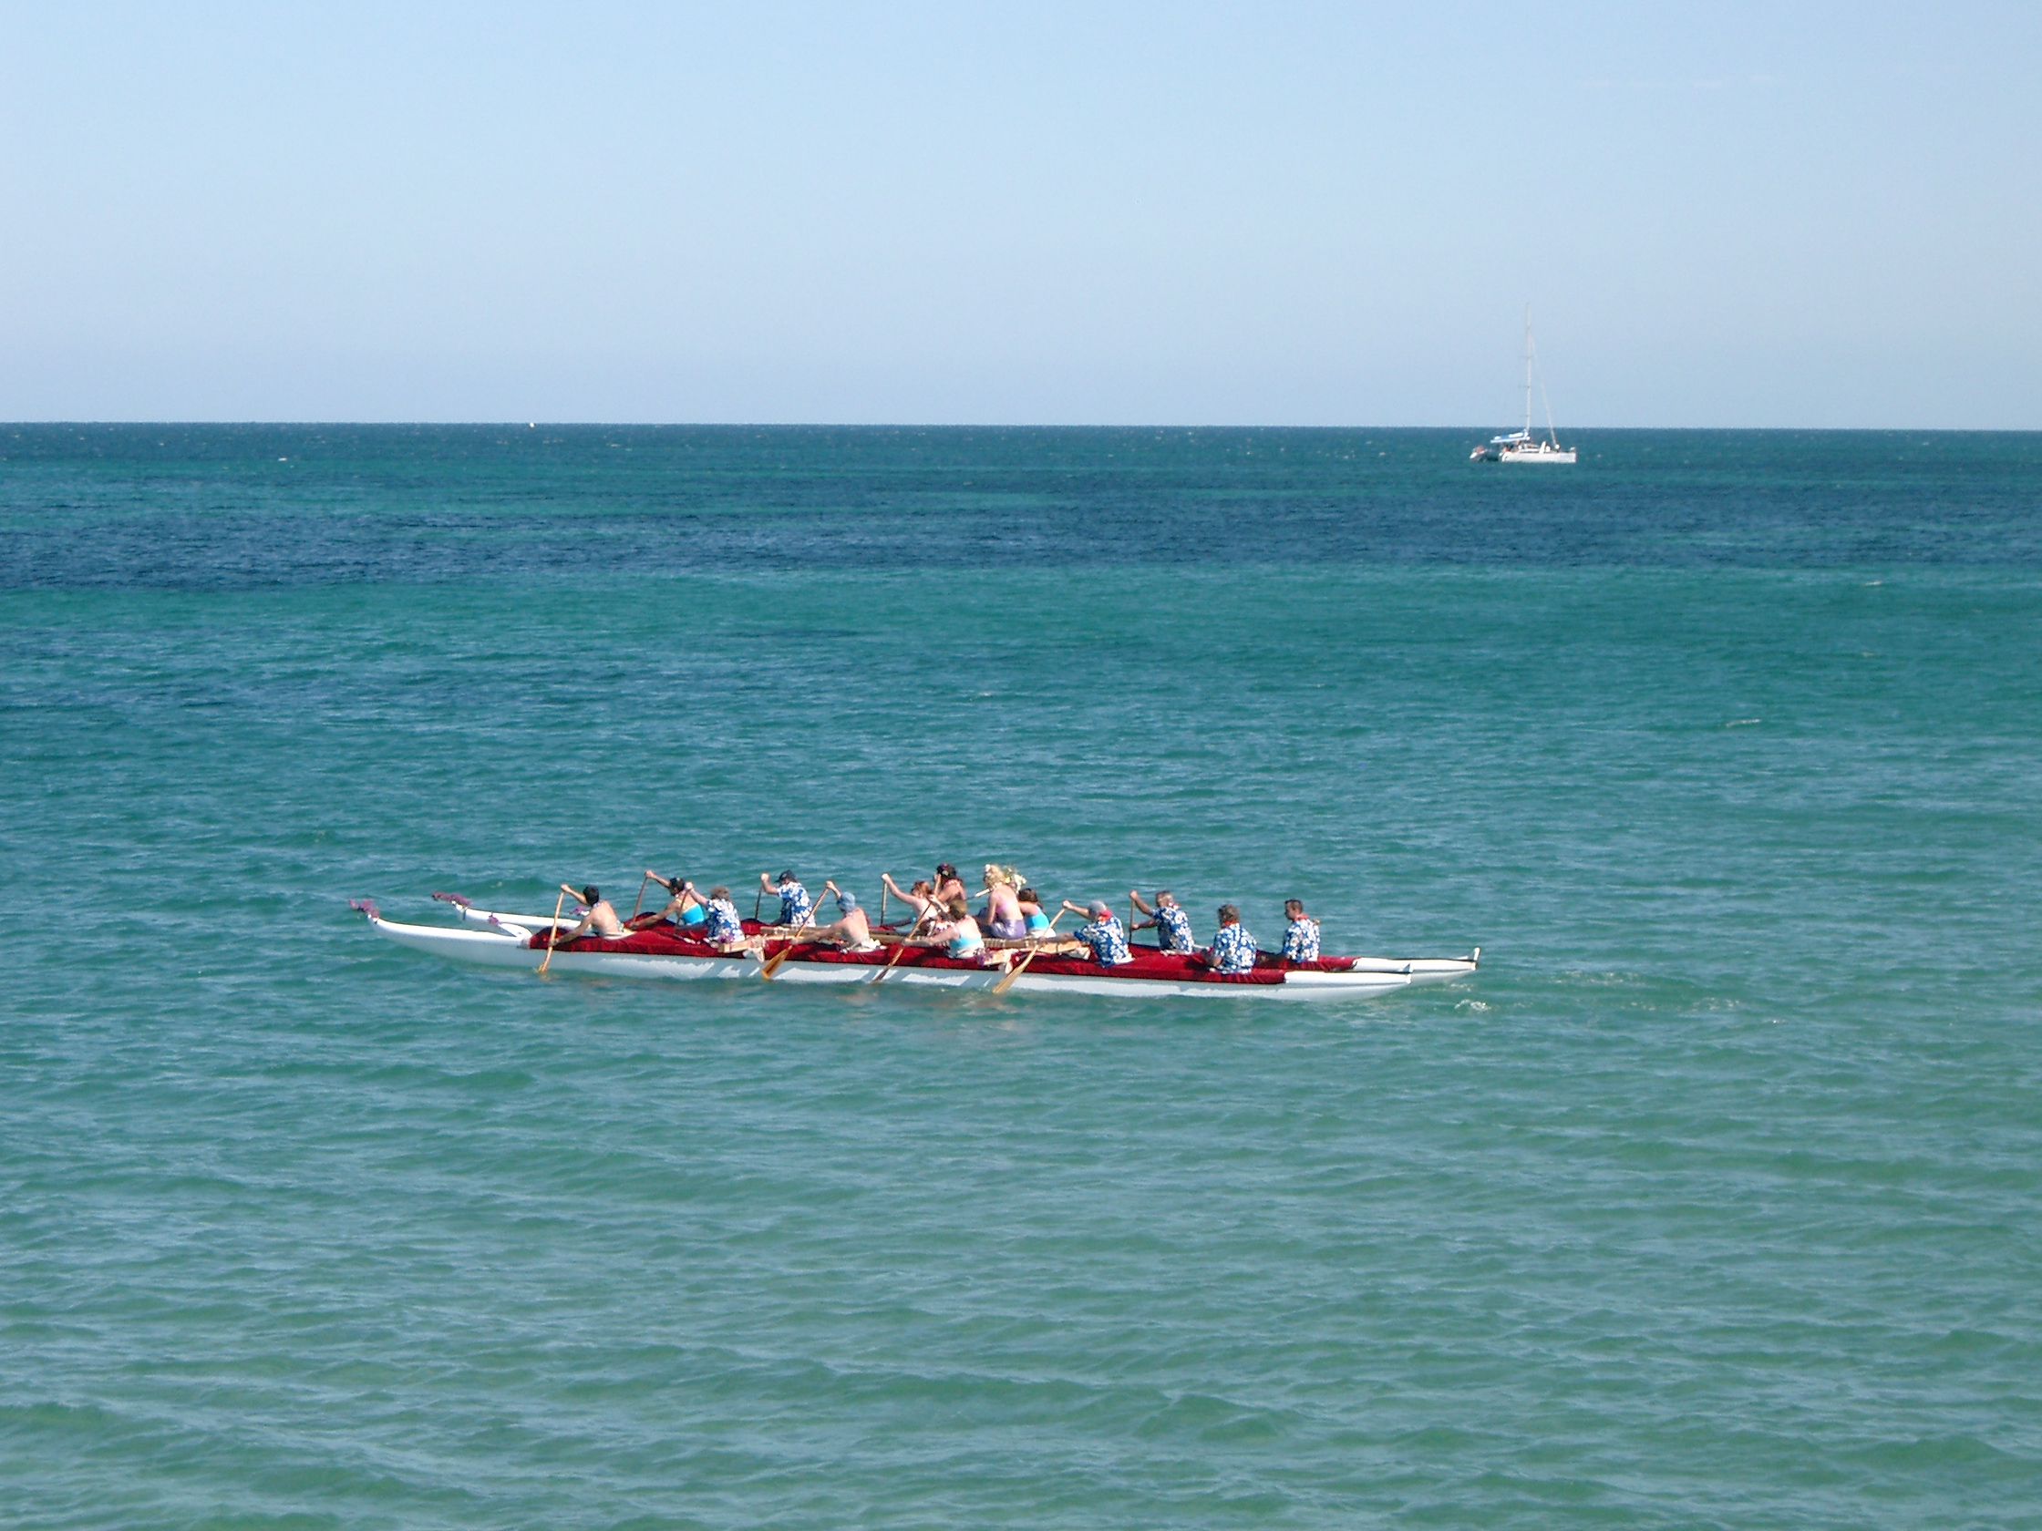

Sponsor Involvement

In 2004 we are expecting to hold our first Regatta which combined with Adelaide Outriggers involvement in Regattas in regional areas like Port Augusta, Tumby Bay, The Murray River Marathon and interstate in Melbourne, Sydney and Hamilton Island
At the Regatta in Port Augusta it is expected that we would attract 200 competitors made up primarily of local businesses and sporting groups. The Murray River Marathon attracts many crews from around Australia and provides local media coverage as well as audiences of locals down the Murray.
Regular regattas interstate on the other hand, regularly attract in the vicinity of 500 competitors. At the Natational Titles held on the Gold Coast each year, there over 1000 competitors from all over Australia with the competition receiving both Television and local press media coverage.
The Hamilton Island race attracts Crews from all around the world-Great Britain, New Zealand, United States (including Hawaii) and of course Australia.
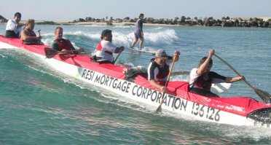

Mutual Benefits

The sponsorship relationship would improve your Company/Business community awareness and promote and market your Company/Business to a broad public audience both locally and interstate.
These events provide the sponsor great public exposure and it presents an opportunity to promote the relationship between Adelaide Outriggers and your Company/Business to the general community.
The season extends from September to June each year which ensures that the Club and sponsors receive a lengthy exposure during the year.
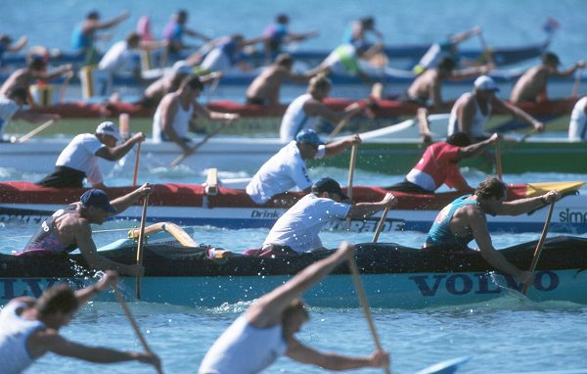

Contact

In the first instance please contact the Club Secretary:
Peter (Biggles) Carr
57 Windsor Grove, Klemzig SA 5087
Ph (0)8 8266 3514
Fx (0)8 8261 7705
Em, Peter.Carr@CarrConsulting.com

